Table of Contents
Chapter-01: Introduction to the Microprocessor and Computer. 2
Chapter-02: The Microprocessor and it’s Architecture. 18
Chapter-03: Addressing modes. 29
Chapter-04: Data Movement Instructions. 35
Chapter-05: Arithmetic and Logic instructions. 41
Chapter-06: Program Control Instructions. 42

Chapter-01: Introduction to the Microprocessor and Computer.
1.Who developed the Analytical Engine?
Charles Babbage
- The 1890 census used a new device called a punched card. Who developed the punched card?
Herman Hollerith
- Who was the founder of IBM Corporation?
Herman Hollerith
- Who developed the first electronic calculator?
Konrad Zuse
- The first electronic computer system was developed for what purpose?
To decode the Enigma code during World Was II
- The first general-purpose, programmable computer was called the ____________.
ENIAC
- The world’s first microprocessor was developed in 1971 by ____________.
Intel Corporation
- Who was the Countess of Lovelace?
Augusta Ada Byron
- Who developed the first high-level programming language called FLOWMATIC?
Grace Hopper
- What is a von Neumann machine?
A machine that stores the instructions of a program in the memory system.
- Which 8-bit microprocessor ushered in the age of the microprocessor?
8080
- The 8085 microprocessor, introduced in 1977, has sold ____________ copies.
200 million
- Which Intel microprocessor was the first to address 1M bytes of memory?
8086/8088
- The 80286 addresses ____________ bytes of memory.
16M bytes
- How much memory is available to the 80486 microprocessor?
4G bytes
- When did Intel introduce the Pentium microprocessor?
1993
- When did Intel introduce the Pentium Pro processor?
1995
- When did Intel introduce the Pentium 4 microprocessor?
2000
- Which Intel microprocessor addresses 1T of memory?
80486 through the Core2
- What is the acronym MIPs?
Millions of instructions per second
- What is the acronym CISC?
Complex Instruction Set Computer
- A binary bit stores a(n) ____________or a(n) ____________. A binary bit stores a 1 or a 0.
- A computer K (pronounced kay) is equal to ____________ bytes.
1024
- A computer M (pronounced meg) is equal to ____________ K bytes.
1024K
- A computer G (pronounced gig) is equal to ____________ M bytes.
1024
- A computer P (pronounced peta) is equal to ____________ T bytes.
1024
- How many typewritten pages of information are stored in a 4Gbyte memory?
1,000,000
- The first 1M byte of memory in a DOS-based computer system contains a(n) ____________and a(n) ____________area.
System area and transient program area
- How large is the Windows application programming area? 2Giga or 3Giga for 32-bit mode and currently 8Giga for 64-bit mode
- How much memory is found in the DOS transient program area?
640K
- How much memory is found in the Windows systems area?
1Giga
- The 8086 microprocessor addresses ____________ bytes of memory.
1M
- The Core2 microprocessor addresses ____________ bytes of memory.
Currently 1Tera byte using a 40-bit address
- Which microprocessors address 4G bytes of memory?
80386, 80486, Pentium, Pentium Pro, PII, PIII, P4, and Core2
- Memory above the first 1M byte is called ____________ memory. Protected memory or extended memory
- What is the system BIOS?
The basic I/O system
- What is DOS?
An early operating system called the Disk Operating System
- What is the difference between an XT and an AT computer system?
The XT was used with the 8088 and 8086 and beginning with the 80286, the AT became the name of the system.
- What is the VESA local bus?
Video Electronics Standards Association
- The ISA bus holds ____________-bit interface cards.
8-bit and 16-bit
- What is the USB?
Universal Serial Bus
- What is the AGP?
The advanced graphics port is designed to support video cards.
- What is the XMS?
Extended Memory System
- What is the SATA interface and where is it used in a system? The serial ATA interface is designed to support disk drive memory
- A driver is stored in the ____________ area.
System Area
- The personal computer system addresses ____________ bytes of I/O space.
64K
- What is the purpose of the BIOS?
The BIOS controls the computer at its most basic level and provides for compatibility between computers.
- Draw the block diagram of a computer system.
See Figure 1–6.
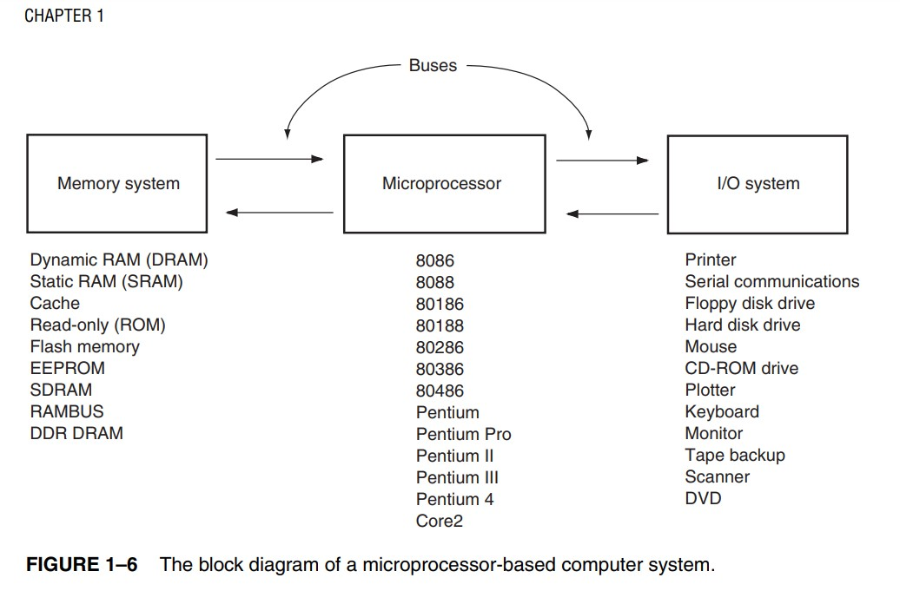
- What is the purpose of the microprocessor in a microprocessorbased computer?
The microprocessor is the controlling element in a computer system.
- List the three buses found in all computer systems.
Address, data, and control buses
- Which bus transfers the memory address to the I/O device or to the memory?
Address bus
- Which control signal causes the memory to perform a read operation?
MRDC
- What is the purpose of the IORC signal?
The I/O read signal causes an I/O device to be read.
- If the MRDC signal is a logic 0, which operation is performed by the microprocessor?
Memory read operation
- Define the purpose of the following assembler directives:
- DB
- DQ
- DW
- DD
- defines a byte or bytes of memory
- defines a quadword or quadwords of memory
- defines a word or words of memory
- defines a doubleword or doublewords of memory
56. Define the purpose of the following 32-bit Visual C++ directives:
- char
- short
- int
- float
- double
- 8-bit signed number
- 16-bit signed number
- 32-bit signed number
- 32-bit floating-point number
- 64-bit floating-point number
57. Convert the following binary numbers into decimal:
- 1101.01
- 111001.0011
- 101011.0101
- 111.0001
(a) 13.25 (b) 57.1875 (c) 43.3125 (d) 7.0625
58. Convert the following octal numbers into decimal:
- 234.5
- 12.3
- 7767.07
- 123.45
- 72.72
(a) 156.625 (b) 18.375 (c) 4087.109375 (d) 83.578125 (e) 58.90625
59. Convert the following hexadecimal numbers into decimal:
- A3.3
- 129.C
- AC.DC
- FAB.3
- BB8.0D

(a) 163.1875 (b) 297.75 (c) 172.859375 (d) 4011.1875 (e) 3000.05078125
60. Convert the following decimal integers into binary, octal, and hexadecimal:
- 23
- 107
- 1238
- 92
- 173

(a) 10111, 27, and 17 (b) 1101011, 153, and 6B (c) 10011010110, 2326, and 4D6 (d) 1011100, 134, and 5C (e) 10101101, 255, and AD
61. Convert the following decimal numbers into binary, octal, and hexadecimal: (a) 0.625
- .00390625
- .62890625
- 0.75
- .9375

(a) 0.101 0.5 0.A (b) 0.0000101 0.024 0.0A (c) 0.10100001 0.502 0.A1 (d) 0.11 0.6 0.C (e) 0.1111 0.74 0.F
62. Convert the following hexadecimal numbers into binary-coded hexadecimal code (BCH):
- 23
- AD4
- 34.AD
- BD32
- 234.3

(a) 0010 0011 (b) 1010 1101 0100 (c) 0011 0100 . 1010 1101 (d) 1011 1101 0011 0010 (e) 0010 0011 0100 . 0011
63. Convert the following binary-coded hexadecimal numbers into hexadecimal:
- 1100 0010
- 0001 0000 1111 1101
- 1011 1100
- 0001 0000
- 1000 1011 1010

(a) C2 (b) 10FD (c) BC (d) 10 (e) 8BA
64. Convert the following binary numbers to the one’s complement form:
- 1000 1000
- 0101 1010
- 0111 0111
- 1000 0000
(a) 0111 0111 (b) 1010 0101 (c) 1000 1000 (d) 0111 1111
65. Convert the following binary numbers to the two’s complement form:
- 1000 0001
- 1010 1100
- 1010 1111
- 1000 0000
(a) 0111 1111 (b) 0101 0100 (c) 0101 0001 (d) 1000 0000
- Define byte, word, and doubleword.
Byte is an 8-bit binary number, word is a 16-bit binary number, doubleword is a 32-bit binary number.
- Convert the following words into ASCII-coded character strings:
- FROG
- Arc
- Water
- Well
(a) 46 52 4F 47, (b) 41 72 63, (c) 57 61 74 65 72, and (d) 57 65 6C 6C
- What is the ASCII code for the Enter key and what is its purpose?
Enter is a 0DH and it is used to return the cursor/print head to the left margin of the screen or page of paper.
- What is the Unicode?
The Unicode is the 16-bit alphanumeric code used with Windows
- Use an assembler directive to store the ASCII-character string ‘What time is it?’ in the memory. LINE1 DB ‘What time is it?’
- Convert the following decimal numbers into 8-bit signed binary numbers:
- +32
- -12
- +100
- -92
(a) 0010 0000 (b) 1111 0100 (c) 0110 0100 (d) 1010 0100 / a) 32
Since this is a positive number. we can directly convert this into binary
Divide 32 successively by 2 until the quotient is 0
> 32/2 = 16, remainder is 0
> 16/2 = 8, remainder is 0
> 8/2 = 4, remainder is 0
> 4/2 = 2, remainder is 0
> 2/2 = 1, remainder is 0
> 1/2 = 0, remainder is 1
Read remainders from the bottom to top as 100000 So, 32 of decimal is 100000 in binary so, 32 in 2's complement binary is 00100000
Answer: 00100000

b) -12
This is negative. so, follow these steps to convert this into a 2's complement binary
Step 1:
Divide 12 successively by 2 until the quotient is 0
> 12/2 = 6, remainder is 0
> 6/2 = 3, remainder is 0
> 3/2 = 1, remainder is 1
> 1/2 = 0, remainder is 1
Read remainders from the bottom to top as 1100
So, 12 of decimal is 1100 in binary
So, 12 in normal binary is 00001100
Step 2: flip all the bits. Flip all 0's to 1 and all 1's to 0.
00001100 is flipped to 11110011
Step 3:. Add 1 to above result 11110011 + 1 = 11110100
so, -12 in 2's complement binary is 11110100
Answer: 11110100

c) 100
Since this is a positive number. we can directly convert this into binary
Divide 100 successively by 2 until the quotient is 0
> 100/2 = 50, remainder is 0
> 50/2 = 25, remainder is 0
> 25/2 = 12, remainder is 1
> 12/2 = 6, remainder is 0
> 6/2 = 3, remainder is 0
> 3/2 = 1, remainder is 1
> 1/2 = 0, remainder is 1
Read remainders from the bottom to top as 1100100 So, 100 of decimal is 1100100 in binary so, 100 in 2's complement binary is 01100100
Answer: 01100100
d) -92
This is negative. so, follow these steps to convert this into a 2's complement binary Step 1:
Divide 92 successively by 2 until the quotient is 0
> 92/2 = 46, remainder is 0
> 46/2 = 23, remainder is 0
> 23/2 = 11, remainder is 1
> 11/2 = 5, remainder is 1
> 5/2 = 2, remainder is 1
> 2/2 = 1, remainder is 0
> 1/2 = 0, remainder is 1
Read remainders from the bottom to top as 1011100
So, 92 of decimal is 1011100 in binary
So, 92 in normal binary is 01011100
Step 2: flip all the bits. Flip all 0's to 1 and all 1's to 0.
01011100 is flipped to 10100011
Step 3:. Add 1 to above result 10100011 + 1 = 10100100
so, -92 in 2's complement binary is 10100100
Answer: 10100100
72. Convert the following decimal numbers into signed binary words:
- +1000
- -120
- +800
- -3212
(a) 0000 0011 1110 1000 (b) 1111 1111 1000 1000 (c) 0000 0011 0010
0000 (d) 1111 0011 0111 0100 /
using 16-bits for representing the binary words a) 1000 1000 Since this is a positive number. we can directly convert this into binary Divide 1000 successively by 2 until the quotient is 0 > 1000/2 = 500, remainder is 0 > 500/2 = 250, remainder is 0 > 250/2 = 125, remainder is 0 > 125/2 = 62, remainder is 1 > 62/2 = 31, remainder is 0 > 31/2 = 15, remainder is 1 > 15/2 = 7, remainder is 1 > 7/2 = 3, remainder is 1 > 3/2 = 1, remainder is 1 > 1/2 = 0, remainder is 1 Read remainders from the bottom to top as 1111101000 So, 1000 of decimal is 1111101000 in binary so, 1000 in 2's complement binary is 0000001111101000 Answer: 0000001111101000 b) -120 -120 This is negative. so, follow these steps to convert this into a 2's complement binary Step 1: Divide 120 successively by 2 until the quotient is 0 > 120/2 = 60, remainder is 0 > 60/2 = 30, remainder is 0 > 30/2 = 15, remainder is 0 > 15/2 = 7, remainder is 1 > 7/2 = 3, remainder is 1 > 3/2 = 1, remainder is 1 > 1/2 = 0, remainder is 1 Read remainders from the bottom to top as 1111000 So, 120 of decimal is 1111000 in binary So, 120 in normal binary is 0000000001111000 Step 2: flip all the bits. Flip all 0's to 1 and all 1's to 0. 0000000001111000 is flipped to 1111111110000111 Step 3:. Add 1 to above result 1111111110000111 + 1 = 1111111110001000 so, -120 in 2's complement binary is 1111111110001000 Answer: 1111111110001000 c) 800 800 Since this is a positive number. we can directly convert this into binary Divide 800 successively by 2 until the quotient is 0 > 800/2 = 400, remainder is 0 > 400/2 = 200, remainder is 0 > 200/2 = 100, remainder is 0 > 100/2 = 50, remainder is 0 > 50/2 = 25, remainder is 0 > 25/2 = 12, remainder is 1 > 12/2 = 6, remainder is 0 > 6/2 = 3, remainder is 0 > 3/2 = 1, remainder is 1 > 1/2 = 0, remainder is 1 Read remainders from the bottom to top as 1100100000 So, 800 of decimal is 1100100000 in binary so, 800 in 2's complement binary is 0000001100100000 Answer: 0000001100100000 d) -3212 -3212 This is negative. so, follow these steps to convert this into a 2's complement binary Step 1: Divide 3212 successively by 2 until the quotient is 0 > 3212/2 = 1606, remainder is 0 > 1606/2 = 803, remainder is 0 > 803/2 = 401, remainder is 1 > 401/2 = 200, remainder is 1 > 200/2 = 100, remainder is 0 > 100/2 = 50, remainder is 0 > 50/2 = 25, remainder is 0 > 25/2 = 12, remainder is 1 > 12/2 = 6, remainder is 0 > 6/2 = 3, remainder is 0 > 3/2 = 1, remainder is 1 > 1/2 = 0, remainder is 1 Read remainders from the bottom to top as 110010001100 So, 3212 of decimal is 110010001100 in binary So, 3212 in normal binary is 0000110010001100 Step 2: flip all the bits. Flip all 0's to 1 and all
1's to 0. 0000110010001100 is flipped to 1111001101110011 Step
3:. Add 1 to above result 1111001101110011 + 1 = 1111001101110100 so, -3212 in 2's complement binary is 1111001101110100 Answer: 1111001101110100
- Use an assembler directive to store byte-sized -34 into the memory.
DB -34
- Create a byte-sized variable called Fred1 and store a -34 in it in Visual C++.
char Fred1 = –34

- Show how the following 16-bit hexadecimal numbers are stored in the memory system (use the standard Intel little endian format):
- 1234H
- A122H
- B100H
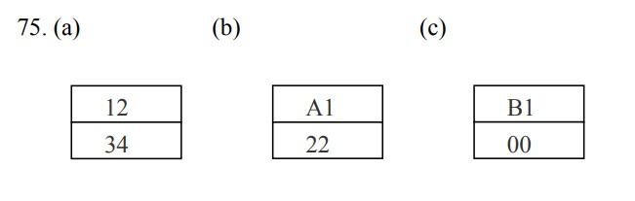
- What is the difference between the big endian and little endian formats for storing numbers that are larger than 8 bits in width?
Little endian numbers are stored so the least significant portion is in the lowest numbered memory location and big-endian numbers are stored so the most significant part is stored in the lowest numbered memory location.
- Use an assembler directive to store a 123A hexadecimal into memory.
DW 1234H
- Convert the following decimal numbers into both packed and unpacked BCD forms:
- 102
- 44
- 301
- 1000
- packed = 00000001 00000010 and unpacked 00000001 00000000 00000010
- packed = 01000100 and unpacked 00000100 00000100
- packed = 00000011 00000001 and unpacked 00000011 00000000 00000001
- packed = 00010000 00000000 and unpacked 00000001 00000000 00000000 00000000
/
Packed BCD form: Allocating Every decimal number into 4-bit binary equivalent is called as packed BCD form.
Unpacked BCD form: allocating every element decimal number into 8-bit binary equivalent, nibble is included if needed. it is known as the Unpacked BCD form.

79. Convert the following binary numbers into signed decimal numbers:
- 10000000
- 00110011
- 10010010
- 10001001
- –0 (b) +51 (c) –18 (d) –9 /
To convert to signed decimal just leave the leftmost bit of the binary number since it is the sign bit and find the decimal number for the rest part. if leftmost bit (MSB) is 1 no. is negative else it is positive. (a) 10000000 -----> Since MSB is 1 no. will be negative leave it and find decimal for rest part.
0000000 ----> (0 × 26 + 0 × 25 + 0 × 24 + 0 × 23 + 0 × 22 + 0 × 21 + 0 × 20) = (0 + 0 + 0 + 0 + 0 + 0 + 0) = 0
So putting negative sign before 0 we get signed decimal > -0

- 00110011 ----> Since MSB is 0 no. will be positive leave it and find decimal for rest part.
0110011 --> (0 × 26 + 1 × 25 + 1 × 24 + 0 × 23 + 0 × 22 + 1 × 21 + 1 × 20) = (0 + 32 + 16 + 0 + 0 + 2 + 1) = (32 + 16 + 2 + 1) = 51
So putting positive sign before 51 we get signed decimal > +51

- 10010010 -----> Since MSB is 1 no. will be negative leave it and find decimal for rest part.
0010010 ----> (0 × 26 + 0 × 25 + 1 × 24 + 0 × 23 + 0 × 22 + 1 × 21 + 0 × 20) = (0 + 0 + 16 + 0 + 0 + 2 + 0) = (16 + 2) = 18
So putting negative sign before 0 we get signed decimal > -18

- 10001001-----> Since MSB is 1 no. will be negative leave it and find decimal for rest part.
0001001 ---->(0 × 26 + 0 × 25 + 0 × 24 + 1 × 23 + 0 × 22 + 0 × 21 + 1 × 20) = (0 + 0 + 0 + 8 + 0 + 0 + 1) = (8 + 1) = 9
So putting negative sign before 0 we get signed decimal > -9
80. Convert the following BCD numbers (assume that these are packed numbers) to decimal numbers:
- 10001001
- 00001001
- 00110010
- 00000001
- 89 (b) 09 (c) 32 (d) 01

81. Convert the following decimal numbers into single-precision floating-point numbers:
- +1.5
- –10.625
- +100.25
- –1200
- 0 01111111 10000000000000000000000
- 1 10000010 01010100000000000000000
- 0 10000101 10010001000000000000000
- 1 10001001 00101100000000000000000
/
Details ans below
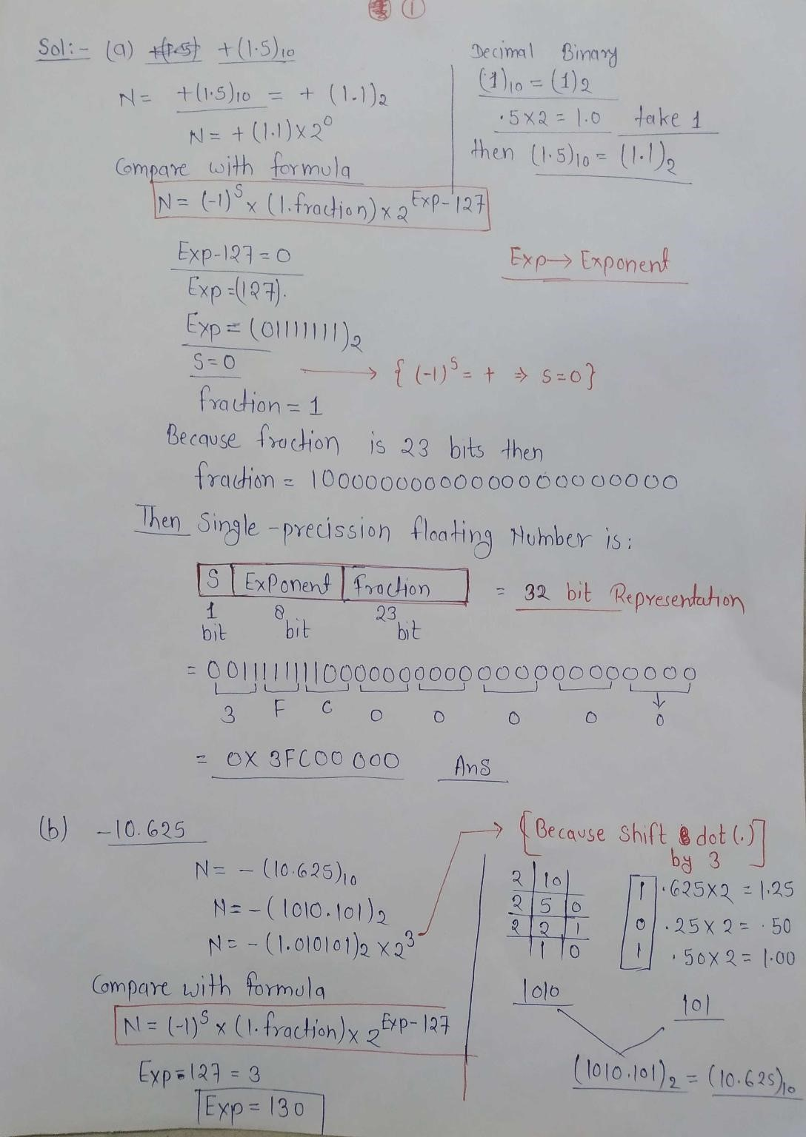
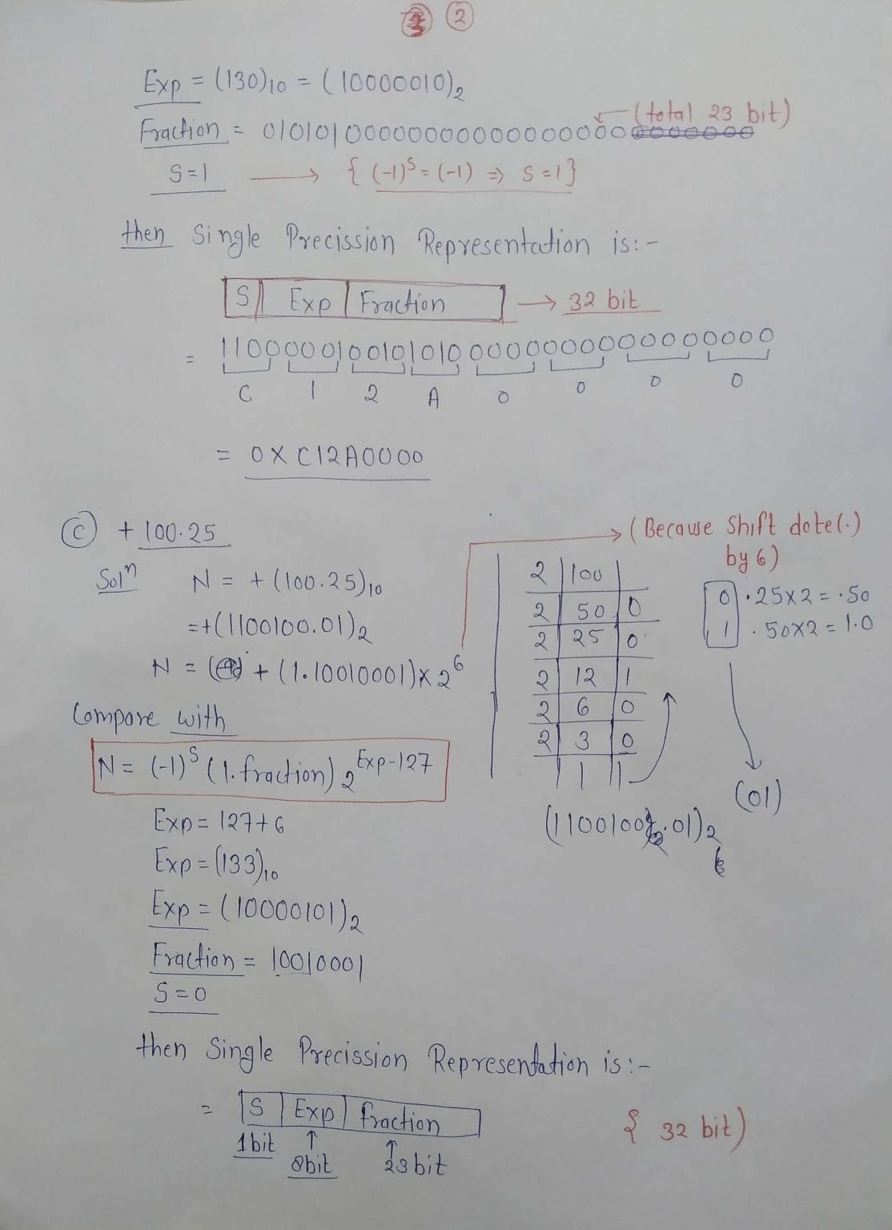
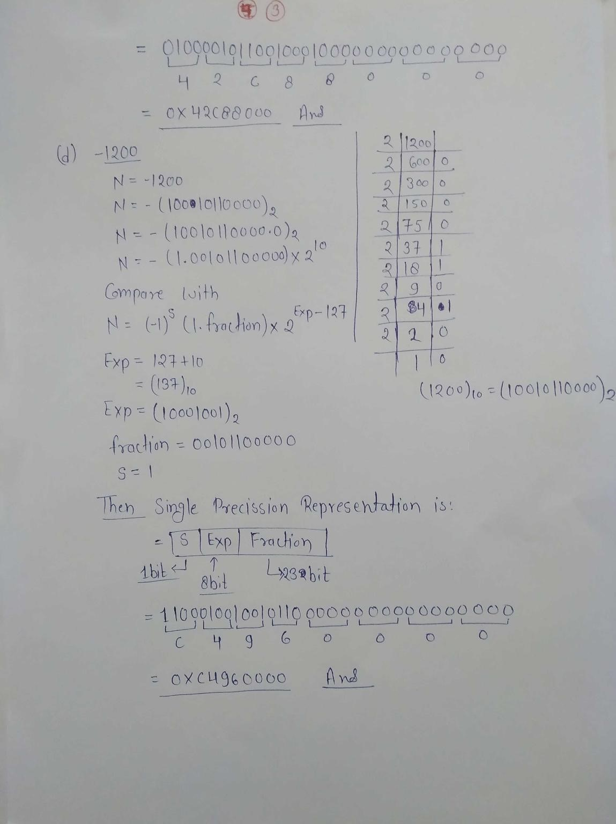

82. Convert the following single-precision floating-point numbers into decimal numbers:
- 0 10000000 11000000000000000000000
- 1 01111111 00000000000000000000000
- 0 10000010 10010000000000000000000
(a) +3.5 (b) -1.0 (c) +12.5 /
83. Use the Internet to write a short report about any one of the following computer pioneers:
- Charles Babbage
- Konrad Zuse
- Joseph Jacquard
- Herman Hollerith
84. Use the Internet to write a short report about any one of the following computer languages:
- COBOL
- ALGOL
- FORTRAN
- PASCAL
- Use the Internet to write a short report detailing the features of the Itanium 2 microprocessor.
- Use the Internet to detail the Intel 45 nm (nanometer) fabrication technology

Chapter-02: The Microprocessor and it’s Architecture.
- What are program-visible registers?
Program visible register are the registers that are directly used in an instruction
- The 80286 addresses registers that are 8 and _________ bits wide.
16
- The extended registers are addressable by which microprocessors?
The 80386 through the Core2
- The extended BX register is addressed as _________.
EBX
- Which register holds a count for some instructions?
CL, CX, ECX, or RCX
- What is the purpose of the IP/EIP register?
Holds the offset address of the next step in the program. The IP/EIP register is used to store the address of the next instruction. The instruction pointer, which points to the next instruction in a program, is used by the microprocessor to find the next sequential instruction in a program located within the code segment.
- The carry flag bit is not modified by which arithmetic operations?
INC and DEC. The carry flag bit is not modified by multiplication and division operations.
- Will an overflow occur if a signed FFH is added to a signed 01H?
No, if you add +1 and –1 you have zero, which is a valid number
- A number that contains 3 one bits is said to have _________ parity.
Odd
- Which flag bit controls the INTR pin on the microprocessor?
The I-flag. / The I(interrupt) flag controls the INTR(interrupt request) pin. If I = 1, INTR pins enabled, if I = 0, the INPR is disabled.
- Which microprocessors contain an FS segment register?
The 80386 through the Core2
- What is the purpose of a segment register in the real mode operation of the microprocessor?
The segment register addresses the lowest address in a 64K memory segment. /
The Segment Registers are the additional registers which generates addresses when combined with other registers in the microprocessor. In protected mode, segment registers simply point to data structures called segment descriptors that contain the information needed to access a physical memory location.
The Segment registers are the following :
  - CS(code) : The code segment register defines the starting address of the section of memory holding code. In real mode operation, it defines the start of a 64K- byte section of memory; in protected mode, it selects a descriptor that describes the starting address and length of a section of memory holding code
  - 2. DS(Data): The data segment is a section of memory that contains most data used by a program. Data are accessed in the data segment by an offset address or the contents of other registers that hold the offset address.
  - 3. ES (Extra) : The extra segment is an additional data segment that is used by some of the string instructions to hold destination data.
  - 4. SS (Stack) : The stack segment defines the area of memory used for the stack. The stack entry point is determined by the stack segment and stack pointer registers
  - 5. FS and GS: The FS and GS segments are supplemental segment registers available in the 80386–Core2
microprocessors to allow two additional memory segments for access by programs.

- In the real mode, show the starting and ending addresses of each segment located by the following segment register values:
- 1000H
- 1234H
- 2300H
- E000H
- AB00H
(a) 1000H
starting address = 10000H ending address = 10000H + FFFFH ending address = 1FFFFH

- 1234H
starting address = 12340H ending address = 12340H + FFFFH ending address = 2233FH

- 2300H
starting address = 23000H ending address = 23000H + FFFFH ending address = 32FFFH

- E000H
starting address = E0000H ending address = E0000H + FFFFH ending address = EFFFFH
- AB00H
starting address = AB000H ending address = AB000H + FFFFH ending address = BAFFFH
14. Find the memory address of the next instruction executed by the microprocessor, when operated in the real mode, for the following CS:IP combinations:
(a) CS = 1000H and IP = 2000H
(b)CS = 2000H and IP = 1000H
(c)CS = 2300H and IP = 1A00H
(d)CS = 1A00H and IP = B000H
(e)CS = 3456H and IP = ABCDH
- CS = 1000H and IP = 2000H
CS : 10000H
IP : +2000H
Next instruction memory address: 12000H
- CS = 2000H and IP = 1000H
CS : 20000H
IP : +1000H
Next instruction memory address : 21000H
- CS = 2300H and IP = 1A00H
CS : 23000H
IP +1A00H
Next instruction memory address : 24A000H

- CS = 1A00H and IP = B000H
CS : 1A000H
IP : +B000H
Next instruction memory address : 25000H

- CS = 3456H and IP = ABCDH
CS : 34560H
IP : +ABCDH
Next instruction memory address : 3F12DH
- Real mode memory addresses allow access to memory below which memory address?
100000H / 1 MB or less
- Which register or registers are used as an offset address for the string instruction destination in the microprocessor?
The Destination Index(DI) register is used as an offset address for the string instruction destination in the microprocessor. DI is a 16-bit register. It is used in the pointer addressing of data and as a destination in some string related operations.
- Which 32-bit register or registers are used to hold an offset address for data segment data in the Pentium 4 microprocessor?
EAX, EBX, ECX, EDX, EBP, ESI, and EDI
- The stack memory is addressed by a combination of the_________segment plus_________ offset.
The stack memory is addressed by a combination of the Stack segment plus SP or ESP offset.
- If the base pointer (BP) addresses memory, the _________ segment contains the data.
Stack
- Determine the memory location addressed by the following real mode 80286 register combinations: (e)SS = 2900H and SP = 3A00H
(d)DS = A000H and BX = 1000H
(c)SS = 2300H and BP = 3200H
(b)DS = 2000H and SI = 1002H
(a)DS = 1000H and DI = 2000H

- DS = 1000H and DI = 2000H
Ans. DS = 10000H, DI = 2000H
Memory Location Accessed = DS + DI
= 10000H + 2000H
= 12000H

- DS = 2000H and SI = 1002H
Ans. DS = 20000H, DI = 1002H
Memory Location Accessed = DS + DI
= 20000 + 1002H
= 21002H
- SS = 2300H and BP = 3200H
Ans. DS = 23000H, DI = 3200H
Memory Location Accessed = DS + DI
= 23000 + 3200H
= 26200H

- DS = A000H and BX = 1000H
Ans. DS = A0000H, DI = 1000H
Memory Location Accessed = DS + DI
= A0000 + 1000H
= A1000H

- SS = 2900H and SP = 3A00H
Ans. DS = 29000H, DI = 3A00H
Memory Location Accessed = DS + DI
= 29000H + 3A00H
= 3F12DH

21. Determine the memory location addressed by the following real mode Core2 register combinations:
(e)DS = 1239H and EDX = 0000A900H
(d)SS = 8000H and ESP = 00009000H
(c)DS = C000H and ESI = 0000A000H
(b)DS = 1A00H and ECX = 00002000H
(a)DS = 2000H and EAX = 00003000H
- DS = 2000H and EAX = 00003000H
Ans. DS = 20000H, EAX = 00003000H
Memory Location Accessed = DS + EAX
= 20000H + 00003000H
= 23000H

- DS = 1A00H and ECX = 00002000H
Ans. DS = 1A000H, ECX = 00002000H
Memory Location Accessed = DS + ECX
= 1A000H + 00002000H
= 1C000H

- DS = C000H and ESI = 0000A000H
Ans. DS = C0000H, ESI = 0000A000H
Memory Location Accessed = DS + ESI
= C0000H + 0000A000H
= CA000H

- SS = 8000H and ESP = 00009000H
Ans. DS = 80000H, ESP = 00009000H
Memory Location Accessed = DS +ESP
= 80000H + 00009000H
= 89000H

- DS = 1239H and EDX = 0000A900H
Ans. DS = 12390H, EDX = 0000A900H
Memory Location Accessed = DS + EDX
= 12390H + 0000A9000H
= 1CC90H
- Protected mode memory addressing allows access to which area of the memory in the 80286 microprocessor?
All 16M bytes / Below 1 MB and above 1 MB.
- Protected mode memory addressing allows access to which area of the memory in the Pentium 4 microprocessor?
Any location in the memory system / 64 TeraBytes.
- What is the purpose of the segment register in protected mode memory addressing?
The segment register is a selector that selects the descriptor from a descriptor table. It also sets privilege level of the request and chooses either the global or local table.
- How many descriptors are accessible in the global descriptor table in the protected mode?
8,192
- For an 80286 descriptor that contains a base address of A00000H and a limit of 1000H, what starting and ending locations are addressed by this descriptor?
A00000H–A01000H /
Base address = A00000H , Limit = 1000H
Starting Address = A000000H
Ending Address = Base Address + Limit
= A00000H + 1000H
= A010000H
- For a Core2 descriptor that contains a base address of 01000000H, a limit of 0FFFFH, and G = 0 , what starting and ending locations are addressed by this descriptor?
01000000H—0100FFFFH /
Starting address = 01000000H
Since, G = 0, we will limit will be the same.
Ending address = 01000000H + 0FFFFH
= 0100FFFFH
- For a Core2 descriptor that contains a base address of 00280000H, a limit of 00010H, and G = 1, what starting and ending locations are addressed by this descriptor?
00280000H–00290FFFH /
Starting address = 00280000H
Since, G = 1, value of the limit is mutliplied 4K bytes( append FFF to the limit)
Limit = 00010FFFH
Ending address = 00280000H + 00010FFFH
= 00290000H
- If the DS register contains 0020H in a protected mode system, which global descriptor table entry is accessed?
4 /
In the DS register,
DS = 0020H
DS = 0000 0000 0010 0000H
So, TI = 0 4 the entry of global descriptor table will be accessed.
30. If DS = 0103H in a protected mode system, the requested privilege level is _________.
3 /
0103 = 0000 0001 0000 0011
RPL = 11
- If DS = 0105H in a protected mode system, which entry, table, and requested privilege level are selected? Descriptor 20H, local table, a privilege ring 1 / 0105H = 0000 0001 0000 0101b.
From this, we can say that the requested privilege level is high(01), table
is local table, entry is 0 0000 0010 0000b = 20H
32th entry
- What is the maximum length of the global descriptor table in the Pentium 4 microprocessor?
64K /
No of entries in the global descriptor table is 8192 Each descriptor is 8 bytes long,
so max length of the global descriptor table = 8192 * 8
= 64K bytes

- Code a descriptor that describes a memory segment that begins at location 210000H and ends at location 21001FH. This memory segment is a code segment that can be read. The descriptor is for an 80286 microprocessor.
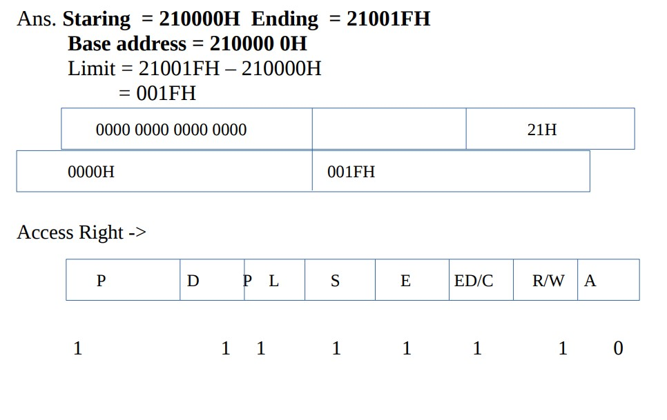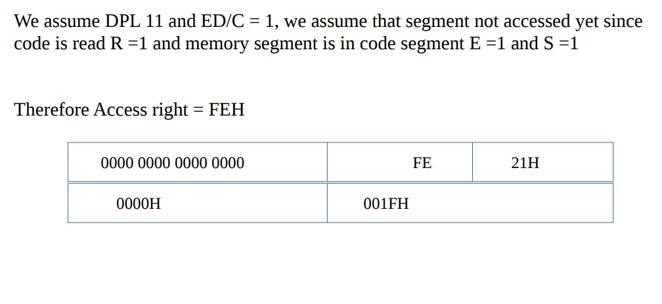
- Code a descriptor that describes a memory segment that begins at location 03000000H and ends at location 05FFFFFFH. This memory segment is a data segment that grows upward in the memory system and can be written. The descriptor is for a Pentium 4 microprocessor.
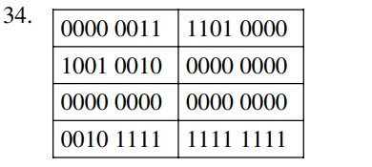
/
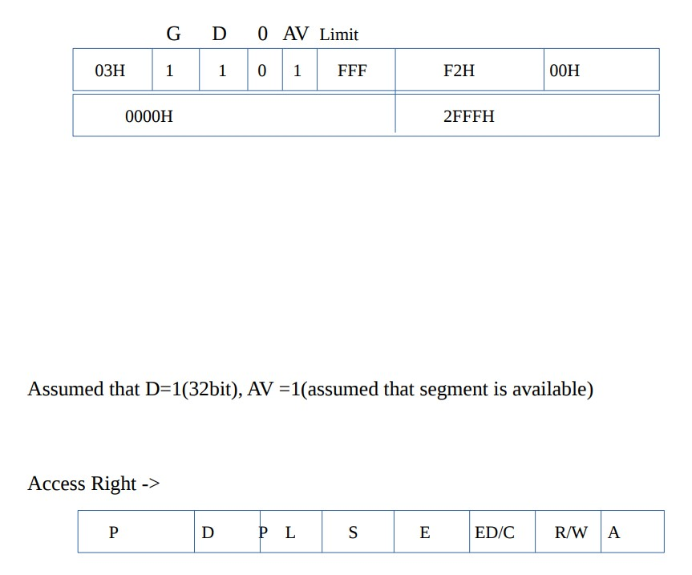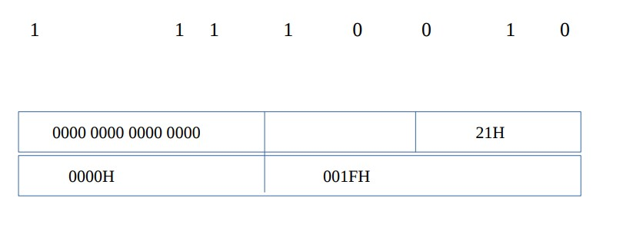 S
- Which register locates the global descriptor table?
GDTR / The GDTR (global descriptor table register) contain the base address of the global descriptor table and its limit. When the protected mode operation is desired, the address of the global descriptor table and its limit are loaded into the GDTR.
- How is the local descriptor table addressed in the memory system?
Through a descriptor stored in the global table
- Describe what happens when a new number is loaded into a segment register when the microprocessor is operated in the protected mode.
The internal cache is loaded with the base address, offset address, and access rights byte
- What are the program-invisible registers?
The program invisible registers are the cache portions of the segment registers and also the GDTR, LDTR, and IDTR registers.
- What is the purpose of the GDTR?
The GDTR address the Global Descriptor Table
- How many bytes are found in a memory page?
4Kilo
- What register is used to enable the paging mechanism in the 80386, 80486, Pentium, Pentium Pro, Pentium 4, and Core2 microprocessors?
4,096
- How many 32-bit addresses are stored in the page directory?
1024
- Each entry in the page directory translates how much linear memory into physical memory?
4M
- If the microprocessor sends linear address 00200000H to the paging mechanism, which paging directory entry is accessed, and which page table entry is accessed?
Entry zero or the first entry
- What value is placed in the page table to redirect linear address 20000000H to physical address 30000000H?
30000000H
- What is the purpose of the TLB located within the Pentium class microprocessor?
The TLB caches the most recent memory accesses through the paging mechanism.
- Using the Internet, write a short report that details the TLB. Hint:
You might want to go to the Intel Web site and search for information.
- Locate articles about paging on the Internet and write a report detailing how paging is used in a variety of systems.
- What is the flat mode memory system?
The flat mode memory system is used with 64-bit operation of the Core2
- A flat mode memory system in the current version of the 64-bit Pentium 4 and Core2 allow these microprocessors to access _________ bytes of memory
1Tera

Chapter-03: Addressing modes.
1. What do the following MOV instructions accomplish?
- MOV AX,BX
- MOV BX,AX
- MOV BL,CH
- MOV ESP,EBP
- MOV RAX,RCX
- the contents of BX is copied into AX
- The contents of AX are copied into BX
- the contents of CH are copied into BL
- the contents of EBP are copied into ESP
- the contents of RCX are copied into RAX
- List the 8-bit registers that are used for register addressing.
AL, AH, BL, BH, CL, CH, DL, and DH
- List the 16-bit registers that are used for register addressing.
AX, BX, CX, DX, SP, BP, SI, DI, CS, DS, ES, SS, FS, and GS
- List the 32-bit registers that are used for register addressing in the 80386 through the Core2 microprocessors. EAX, EBX, ECX, EDX, ESP, EBP, EDI, and ESI
- List the 64-bit registers available to the 64-bit mode of the Pentium 4 and Core2.
RAX, RBX, RCX, RDX, RSP, RBP, RSI, RDI and R8—R15
- List the 16-bit segment registers used with register addressing by MOV, PUSH, and POP.
CS, DS, ES, SS, FS, and GS
- What is wrong with the MOV BL,CX instruction?
BL is of 8bits and CX is of 16 bits,The register sizes must be equal, 16bit cannot be fit into 8-bits.
- What is wrong with the MOV DS,SS instruction?
You may not specify mixed register sizes. because segment to segment transfer is not allowed
- Select an instruction for each of the following tasks:
- copy EBX into EDX
- copy BL into CL
- copy SI into BX
- copy DS into AX
- copy AL into AH
- copy R8 into R10
- MOV EDX,EBX
- MOV CL,BL
- MOV BX,SI
- MOV AX,DS
- MOV AH,AL
- MOV R10,R8
10. Select an instruction for each of the following tasks:
- move 12H into AL
- move 123AH into AX
- move 0CDH into CL
- move 1000H into RAX
- move 1200A2H into EBX
- MOV AL,12H
- MOV AX,123AH
- MOV CL,0CDH
- MOV RAX,1000H
- MOV EBX,1200A2H
- What special symbol is sometimes used to denote immediate data?
#
- What is the purpose of the .MODEL TINY statement?
Selects an assembly language programming model that contains a single segment that compiles as a .COM program.
- What assembly language directive indicates the start of the CODE segment?
.CODE
- What is a label?
A label is a symbolic memory address.

- The MOV instruction is placed in what field of a statement?
Opcode
- A label may begin with what characters?
A label may begin with a letter and some special characters, but not with a number.
- What is the purpose of the .EXIT directive?
It ends the program by exiting to the operating system
- Does the .MODEL TINY statement cause a program to assemble as an execute (.EXE) program?
The .TINY model creates a .COM program
- What tasks does the .STARTUP directive accomplish in the small memory model?
The .STARTUP directive loads the DS register
- What is a displacement? How does it determine the memory address in a MOV DS:[2000H],AL instruction?
A displacement is a distance and in MOV DS:[2000H],AL the displacement of 2000H is added to the contents of DS times 10H to form the memory address.
- What do the symbols [ ] indicate?
Indirect addressing
- Suppose that DS = 0200H, BX = 0300H, and DI = 400H. Determine the memory address accessed by each of the following instructions, assuming real mode operation:
- MOV AL,[1234H]
- MOV EAX,[BX]
- MOV [DI],AL
- DSx10+1234H=2000H+1234H=3234H
- DSx10+300H=2000H+300H=2300H
- DSx10+400H=2000H+400H=2400H
- What is wrong with a MOV [BX],[DI] instruction?
Memory to memory transfers are not allowed with the MOV
instruction
- Choose an instruction that requires BYTE PTR.
MOV BYTE PTR [2000H],6
- Choose an instruction that requires WORD PTR.
INC WORD PTR [EDI]

- Choose an instruction that requires DWORD PTR.
MOV DWORD PTR DATA1, 5
- Select an instruction that requires QWORD PTR.
DEC QWORD PTR [RAX]
- Explain the difference between the MOV BX,DATA instruction and the MOV BX,OFFSET DATA instruction.
The MOV BX,DATA instruction copies the word from memory location data into the BX register where the MOV BX,OFFSET DATA instruction copies the offset address of DATA into BX.
- Suppose that DS = 1000H, SS = 2000H, BP = 1000H, and DI = 0100H. Determine the memory address accessed by each of the following instructions, assuming real mode operation:
- MOV AL,[BP+DI ]
- MOV CX,[DI]
- MOV EDX,[BP]
- SSx10+BP+DI=20000H+1000H+100H=21100H
- DSx10+100H=10000H+100H=10100H
- SSx10+BP=20000H+1000H=21000H
- What, if anything, is wrong with a MOV AL,[BX][SI] instruction?
Nothing is wrong with the instruction; it just uses an alternative addressing style
- Suppose that DS = 1200H, BX = 0100H, and SI = 0250H. Determine the address accessed by each of the following instructions, assuming real mode operation: (a) MOV [100H],DL
- MOV [SI+100H],EAX
- MOV DL,[BX+100H ]
- DSx10+100H=12000H+100H=121000H
- DSx10+SI+100H=12000H+250H+100H=12350H
- DSx10+BX+100H=12000H+100H+100H=12000H
32. Suppose that DS = 1100H, BX = 0200H, LIST = 0250H, and SI = 0500H. Determine the address accessed by each of the following instructions, assuming real mode operation:
- MOV LIST[SI],EDX
- MOV CL,LIST[BX+SI ]
- MOV CH,[BX+SI]
(a) 11750H (b) 11950H (c) 11700H
33. Suppose that DS = 1300H, SS = 1400H, BP = 1500H, and SI = 0100H. Determine the address accessed by each of the following instructions, assuming real mode operation: (a) MOV EAX,[BP+200H]
- MOV AL,[ BP+SI-200H ]
- MOV AL,[ SI-0100H]
- SSx10+BP+200H=14000H+1500H+200H=15700H
- SSx10+BP+SI-200H=14000H +1500H +100H-200H=15400H
- DSx10+SI-200=13000H+100H-200H=12F00H
- Which base register addresses data in the stack segment?
BP or as an extended version EBP
- Suppose that EAX = 00001000H, EBX = 00002000H, and DS = 0010H. Determine the addresses accessed by the following instructions, assuming real mode operation:
- MOV ECX,[EAX+EBX ]
- MOV [EAX+2*EBX],CL
- MOV DH,[ EBX+4*EAX+1000H]
(a) 3100H (b) 05100H (c) 07100H
- Develop a data structure that has five fields of one word each named F1, F2, F3, F4, and F5 with a structure name of FIELDS.
FIELDS STRUC
F1 DW ?
F2 DW ?
F3 DW ?
F4 DW ?
F5 DW ?
FIELDS ENDS
- Show how field F3 of the data structure constructed in question 36 is addressed in a program.
- What are the three program memory-addressing modes?
Direct, relative, and indirect
- How many bytes of memory store a far direct jump instruction?
What is stored in each of the bytes?
5, the first byte is the opcode, followed by a two byte segment address, followed by a two byte offset address

- What is the difference between an intersegment and intrasegment jump?
The intersegment jump allows jumps between segments or to anywhere in the memory system while the intrasegment jump allows a jump to any location within the current code segment.
- If a near jump uses a signed 16-bit displacement, how can it jump to any memory location within the current code segment?
±32Kilo
- The 80386 and above use a ____________-bit displacement to jump to any location within the 4G-byte code segment.
32
- What is a far jump?
A far jump always a jump to any location in the memory map
- If a JMP instruction is stored at memory location 100H within the current code segment, it cannot be a ____________ jump if it is jumping to memory location 200H within the current code segment.
Short
- Show which JMP instruction assembles (short, near, or far) if the JMP THERE instruction is stored at memory address 10000H and the address of THERE is:
- 10020H
- 11000H
- 0FFFEH
- 30000H
  - If the memory address of THERE is 10020H,
10020H
-10000H
00020H → 0000 0000 0000 0010 0000
1 byte
1 byte displacement → short jump
  - If the memory address of THERE is 11000H,
11000H
-10000H
01000H → 0000 0001 0000 0000 0000
2 byte
2 byte displacement → near jump
(c) short (d) far (short 1 byte, near 2 byte,far>near)

- Form a JMP instruction that jumps to the address pointed to by the BX register.
JMP BX
- Select a JMP instruction that jumps to the location stored in memory at the location TABLE. Assume that it is a near JMP.
JMP NEAR
- How many bytes are stored on the stack by a PUSH AX?
2
- Explain how the PUSH [DI] instruction functions.
PUSH [DI] places the 16-bit contents of the location addressed by DS and DI onto the stack
- What registers are placed on the stack by the PUSHA instruction? In what order?
AX, CX, DX, BX, SP, BP, DI, and SI in the same order as listed
- What does the PUSHAD instruction accomplish?
Places the 32-bit contents of the register array onto the stack
- Which instruction places the EFLAGS on the stack in the Pentium 4 microprocessor?
PUSHFD
- Is a PUSHA available in the 64-bit mode of the Pentium 4 or the Core2?
No

Chapter-04: Data Movement Instructions.
- The first byte of an instruction is the ____________, unless it contains one of the override prefixes.
Opcode
- Describe the purpose of the D- and W-bits found in some machine language instructions.
The D-bit indicates the direction of flow for the data (REG to R/M or R/M to REG) and the W-bit indicates the size of the data (byte or word/doubleword).
- In a machine language instruction, what information is specified by the MOD field?
The MOD field specifies the type of access for the R/M field and the size of the displacement
- If the register field (REG) of an instruction contains 010 and W = 0, what register is selected, assuming that the instruction is a 16-bit mode instruction?
DL
- How are the 32-bit registers selected for the Pentium 4 microprocessor?
If operated in the 16-bit mode, a register-size and/or address-size prefix is used to specify a 32-bit register
- What memory-addressing mode is specified by R/M = 001 with MOD = 00 for a 16-bit instruction?
DS:[BX+DI]

- Identify the default segment registers assigned to the following:
- SP
- EBX
- DI
- EBP
- SI
(a) SS (b) DS (c) DS (d) SS (e) DS
- Convert an 8B07H from machine language to assembly language.
MOV AX,[BX]
- Convert an 8B9E004CH from machine language to assembly language.
MOV BX,[BP+4C00H]
- If a MOV SI,[BX+2] instruction appears in a program, what is its machine language equivalent?
8B 77 02
- If a MOV ESI,[EAX] instruction appears in a program for the Core2 microprocessor operating in the 16-bit instruction mode, what is its machine language equivalent?
67 66 8B 30
- 67: Address-size override prefix (32-bit address size in a 16-bit code segment).
- 66: Operand-size override prefix (32-bit operand size).
- 8B: Opcode for the MOV instruction.
- 30: Mod R/M byte, where:
3 is the code for the ESI register (destination operand).
0 is the code for the EAX register (source operand).
11 (Alternative). If a MOV ESI,[EAX] instruction appears in a program for the Core2 microprocessor operating in the 32-bit instruction mode, what is its machine language equivalent?
8B 30
- What is the purpose of REX?
The REX prefix, which is used in the 64-bit flat mode, is the register extension that allows the 64-bit registers to be addressed in an instruction.
- What is wrong with a MOV CS, AX instruction?
The contents of CS will change causing an unpredictable jump / You should never change CS without also changing IP. This instruction would most likely cause the system to crash because only the segment portion of the address of the next instruction is changed.
- Form a short sequence of instructions that load the data segment register with a 1000H.
MOV AX,1000H
MOV DS,AX
- The PUSH and POP instructions always transfer a(n) ____________ -bit number between the stack and a register or memory location in the 80386–Core2 microprocessors when operated in the 32-bit mode.
32
- Create an instruction that places RAX onto the stack in the 64-bit mode for the Pentium 4.
PUSH RAX
- What segment register may not be popped from the stack?
CS
- Which registers move onto the stack with the PUSHA instruction?
AX, CX, DX, BX, SP, BP, SI, and DI
- Which registers move onto the stack for a PUSHAD instruction? EAX, EBX, ECX, EDX, ESP, EBP, EDI and ESI
- Describe the operation of each of the following instructions:
- PUSH AX
- POP ESI
- PUSH [BX]
- PUSHFD
- POP DS
- PUSHD 4
- AX is copied to the stack.
- A 32-bit number is retrieved from the stack and placed into ESI.
- The word contents of the data segment memory location addressed by BX is pushed onto the stack.
- EFLAGS are pushed onto the stack.
- A word is retrieved from the stack and placed into DS.
- A 32-bit number 4 is pushed onto the stack.
- Explain what happens when the PUSH BX instruction executes.
Make sure to show where BH and BL are stored. (Assume that SP = 0100H and SS = 0200H.)
The BH register is moved to memory location 020FFH and the BL register is moved to location 020FEH then SP is changed to 00FEH.

- Repeat question 21 for the PUSH EAX instruction.
Bits 24–31 of EAX are stored in location 020FFH, bits 16–23 of EAX are stored into location 020FEH, bits 8–15 of EAX are stored into location 020FDH, and bits 0–7 of EAX are stored into location 020FCH. SP is then decremented by 4 to a value of 00FCH.
- The 16-bit POP instruction (except for POPA) increments SP by ____________.
2
- What values appear in SP and SS if the stack is addressed at memory location 02200H?
There are many possible locations, but SP = 0200H and SS = 0200H is one of them.
- Compare the operation of a MOV DI,NUMB instruction with an LEA DI,NUMB instruction.
The MOV DI,NUMB instruction copies the 16-bit number in the data segment location NUMB into DI while the LEA DI,NUMB loads DI with the offset address of location NUMB.
- What is the difference between an LEA SI,NUMB instruction and a MOV SI,OFFSET NUMB instruction?
Both instruction load the address of NUMB into DI. The difference is that the MOV DI,OFFSET NUMB assembles as a move immediate and the LEA DI,NUMB assembles as an LEA instruction.
- Which is more efficient, a MOV with an OFFSET or an LEA instruction?
The MOV with the OFFSET directive
- Describe how the LDS BX,NUMB instruction operates.
The LDS BX,NUMB instruction loads BX with the word stored at data segment memory location NUMB and DS is loaded from the data segment memory location addressed by NUMB+2.
- What is the difference between the LDS and LSS instructions?
LDS loads DS and LSS loads SS along with another 16-bti register for the offset address
- Develop a sequence of instructions that moves the contents of data segment memory locations NUMB and NUMB+1 into BX, DX, and SI.
MOV BX,NUMB
MOV DX,BX
MOV SI,DX
- What is the purpose of the direction flag?
If the direction flag is cleared it selects auto-increment for the string instructions and if the direction flag is set it selects auto-decrement.
- Which instructions set and clear the direction flag?
CLD clears the direction flag and STD sets the direction flag.
- Which string instruction(s) use both DI and SI to address memory data?
MOVS.

- Explain the operation of the LODSB instruction.
The LODSB instruction copies a byte of data from the data segment memory location addressed by SI into the AL register and then increments SI by one if the direction flag is cleared.
- Explain the operation of the LODSQ instruction for the 64-bit mode of the Pentium 4 or Core2.
A 4-bit number is loaded into RAZ from the data segment memory location addressed by ESI and then ESI is either incremented or decrement by 8 depending on the setting of the direction flag.
- Explain the operation of the OUTSB instruction.
The OUTSB instruction sends the contents of the data segment memory location addressed by SI to the I/O port address by DX, then SI is incremented by one if the direction flag is cleared.
- Explain the operation of the STOSW instruction.
The STOSW instruction copies AX into the extra segment memory location addressed by DI then DI is either incremented or decremented by two as dictated by the direction flag.
- Develop a sequence of instructions that copy 12 bytes of data from an area of memory addressed by SOURCE into an area of memory addressed by DEST.
MOV SI,OFFSET SOURCE
MOV DI,OFFSET DEST
MOV CX,12
REP MOVSB
- What does the REP prefix accomplish and what type of instruction is it used with?
The REP prefix repeats a string instruction CX number of times.
- Select an assembly language instruction that exchanges the contents of the EBX register with the ESI register.
XCHG EBX,ESI
- Where is the I/O address (port number) stored for an INSB instruction?
DX register
- Would the LAHF and SAHF instructions normally appear in software?
The LAHF and SAHF instructions in non-64-bit application with the arithmetic coprocessor.
- Write a short program that uses the XLAT instruction to convert the BCD numbers 0–9 into ASCII-coded numbers 30H–39H. Store the ASCII-coded data in a TABLE located within the data segment.
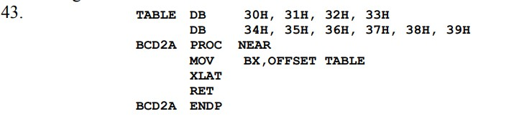

- Explain how the XLAT instruction transforms the contents of the AL register.
The XLAT instruction passes the contents of AL to BX to form an offset address that accesses a memory location whose content is then copied into AL.
- Explain what the IN AL,12H instruction accomplishes. IN AL, 12H copies the byte from I/0 device 12H into AL
- Explain how the OUT DX,AX instruction operates.
The OUT DX,AX instruction copies the 16-bit contents of AX into the data segment memory location addressed by the DX register.
- What is a segment override prefix?
The segment override prefix allows the default segment to be changed to any segment
- Select an instruction that moves a byte of data from the memory location addressed by the BX register in the extra segment into the AH register.
MOV AH,ES:[BX]
- Develop a sequence of instructions that exchanges the contents of AX with BX, ECX with EDX, and SI with DI.
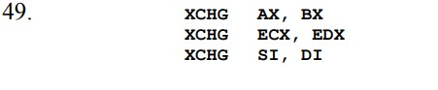
- What is an assembly language directive?
An assembly language directive is a special command to the assembler that may or may not generate code or data for the memory

- What is accomplished by the CMOVNE CX,DX instruction in the Pentium 4 microprocessor?
DX is copied into CX if a not zero or not equal condition exists.
- Describe the purpose of the following assembly language directives: DB, DW, and DD.
The directives, DB, DW, and DD, are used to define memory as a byte (DB), a word (DW), and a doubleword (DD).
- Select an assembly language directive that reserves 30 bytes of memory for array LIST1.
LIST1 DB 30 dup(?)
- Describe the purpose of the EQU directive.
The EQU (equate) directive allows a memory location to be equated to another memory location.
- What is the purpose of the .686 directive?
The .686 directive informs the assembler that a Pentium Pro or newer microprocessor is the target of the assembled program.
- What is the purpose of the .MODEL directive?
The .MODEL directive specifies the type of memory model used for a program.
- If the start of a segment is identified with .DATA, what type of memory organization is in effect? models
- If the SEGMENT directive identifies the start of a segment, what type of memory organization is in effect?
Full segment definitions
- What does the INT 21H accomplish if AH contains a 4CH?
The program terminates and control is passed back to the operating system.
- What directives indicate the start and end of a procedure?
PROC indicates the start of a procedure and ENDP indicates its end.
- Explain the purpose of the USES statement as it applies to a procedure with version 6.x of MASM.
The uses directive specifies which registers are saved on the stack at the beginning of a procedure and popped at the end of the procedure.
- Develop a near procedure that stores AL in four consecutive memory locations within the data segment, as addressed by the DI register.
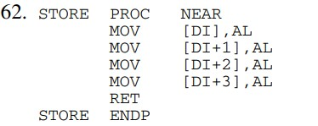
- How is the Pentium 4 microprocessor instructed to use the 16-bit instruction mode?
If the model statement precedes the processor directive the code generated is 16- bit.
- Develop a far procedure that copies contents of the word-sized memory location CS:DATA4 into AX, BX, CX, DX, and SI.
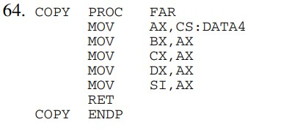

Chapter-05: Arithmetic and Logic instructions.
Click here and read from this site.

Chapter-06: Program Control Instructions.
1. What is a short JMP?
A short jump allows a program to branch forward 127 bytes or backwards 128 bytes from the next instruction’s address in the program.
2. Which type of JMP is used when jumping to any location within the current code segment?
A near JMP instruction
3. Which JMP instruction allows the program to continue execution at any memory location in the system?
Far jump
4. Which JMP instruction is 5 bytes long?
A far jump
5. What is the range of a near jump in the 80386–Core2 microprocessors?
±2G
6. Which type of JMP instruction (short, near, or far) assembles for the following:
(a) if the distance is 0210H bytes
(b) if the distance is 0020H bytes
(c) if the distance is 10000H bytes
(a) near (b) short (c) far
7. What can be said about a label that is followed by a colon?
A label followed by a single colon is a short of near address and a double colon denotes a far address.
8. The near jump modifies the program address by changing which register or registers?
The IP or EIP register
9. The far jump modifies the program address by changing which register or registers?
The code segment register and the instruction address register
10. Explain what the JMP AX instruction accomplishes. Also identify it as a near or a far jump instruction.
The JMP AX instruction jumps to the offset address stored in AX. This can only be a near jump
11. Contrast the operation of a JMP DI with a JMP [DI].
A JMP DI copies the contents of DI into the instruction address register and a JMP [DI] copies the 16-bit number from the data segment memory location addressed by DI into the instruction address register.
12. Contrast the operation of a JMP [DI] with a JMP FAR PTR [DI].
The JMP [DI] instruction jumps to the memory location addressed by the offset address stored in the data segment memory location addressed by DI. The JMP FAR PTR[DI] instruction jumps to the new offset address stored in the data segment memory location addressed by DI and the new segment addressed by the data segment memory location address by DI+2. JMP [DI] is a near jump and JMP FAR PTR [DI] is a far jump.
13. List the five flag bits tested by the conditional jump instructions.
Sign (S), Zero (Z), Carry (C), Overflow (O), and Parity (P)

14. Describe how the JA instruction operates.
JA tests the condition of an arithmetic or logic instruction to determine if the outcome is above. If the outcome is above a jump occurs, otherwise no jump occurs.
15. When will the JO instruction jump?
A JO instruction jumps on an overflow condition
16. Which conditional jump instructions follow the comparison of signed numbers?
JNE, JE, JG, JGE, JL, or JLE
17. Which conditional jump instructions follow the comparison of unsigned numbers?
JNZ, JNE, JZ, JE, JB, JBE, JA, JAE
18. Which conditional jump instructions test both the Z and C flag bits?
JA and JBE
19. When does the JCXZ instruction jump?
Tests the contents of CX and jumps if it is zero
20. Which SET instruction is used to set AL if the flag bits indicate a zero condition?
SETZ or SETE
21. The 8086 LOOP instruction decrements register ____________ and tests it for a 0 to decide if a jump occurs.
CX
22. The Pentium 4 LOOPD instruction decrements register ____________ and tests it for a 0 to decide if a jump occurs.
ECX
23. The Core2 operated in 64-bit mode for a LOOP instruction decrements register____________ and tests it for a 0 to decide if a jump occurs.
RCX
24. Develop a short sequence of instructions that stores 00H into 150H bytes of memory, beginning at extra segment memory location DATAZ. You must use the LOOP instruction to help perform this task.
MOV DI, OFFSET DATAZ
MOV CX,150H
CLD
MOV AL,00H
L1: STOSB
LOOP L1
25.Explain how the LOOPE instruction operates.
The LOOPE instruction jumps is an equal condition exists and CX is not a zero and it also decrements CX on each iteration of the loop.
26. Show the assembly language instructions are generated by the following sequence:
CMP AL,3
JNE @C0001
ADD AL,2
@C0001:
27. Develop a sequence of instructions that searches through a block of 100H bytes of memory. This program must count all the unsigned numbers that are above 42H and all that are below 42H. Byte-sized data segment memory location UP must contain the count of numbers above 42H, and data segment location DOWN must contain the count of numbers below 42H.
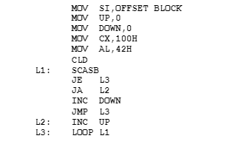
28. Develop a short sequence of instructions that uses the REPEAT-UNTIL construct to copy the contents of byte-sized memory BLOCKA into byte-sized memory BLOCKB until 00H is moved.
MOV SI,OFFSET BLOCKA
MOV DI,OFFSET BLOCKB
CLD
.REPEAT
LODSB
STOSB
.UNTIL AL == 0
29. What happens if the. WHILE 1 instruction is placed in a program?
An infinite loop is created.
30. Using the WHILE construct, develop a sequence of instructions that add the byte-sized contents of BLOCKA to BLOCKB while the sum is not 12H.
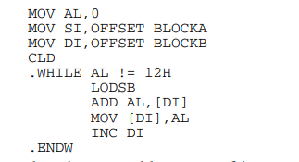
31.What is the purpose of the. BREAK directive?
A BREAK can be used to break out of a .WHILE construct.
32. What is a procedure?
A procedure is a reusable group of instructions that ends with a RET.
33. Explain how the near and far CALL instructions function.
The main difference between a near and a far call is the distance from the call and the type of call and return that assembles.
34. The last executable instruction in a procedure must be a(n) ____________.
RET
35. How does the near RET instruction function?
The near return retrieves the return address from the stack and places it into the instruction address register.
36. How is a procedure identified as near or far?
By using NEAR or FAR to the right of the PROC directive
37. Which directive identifies the start of a procedure?
PROC
38. Write a near procedure that cubes the contents of the CX register. This procedure may not affect any register except CX.
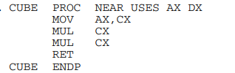
39. Explain what the RET 6 instruction accomplishes.
The RET 6 deletes 6 bytes from the stack before returning from a procedure.
40. Write a procedure that multiplies DI by SI and then divides the result by 100H. Make sure that the result is left in AX upon returning from the procedure. This procedure may not change any register except AX.
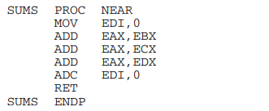
41. Write a procedure that sums EAX, EBX, ECX, and EDX. If a carry occurs, place a logic 1 in EDI. If no carry occurs, place a 0 in EDI. The sum should be found in EAX after the execution of your procedure.
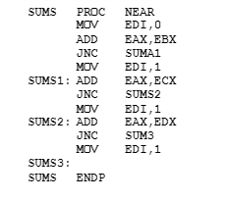
42. What is an interrupt?
An interrupt is a hardware-initiated function call.
43. Which software instructions call an interrupt service procedure?
INT
44. How many different interrupt types are available in the microprocessor?
INT 0 through INT 255
45. Illustrate the contents of an interrupt vector and explain the purpose of each part.
An interrupt vector contains the offset address followed by the segment address in 4 bytes of memory.
46. What is the purpose of interrupt vector type number 0?
The interrupt vector is used to detect and respond to divide errors.

47. How does the IRET instruction differ from the RET instruction?
The IRETD instruction pops the flags, a 32-bit offset address, and the protected mode selector for the CS register.
48. What is the IRETD instruction?
The IRETD instruction is a 32-bit return that pops the return address into EIP.
49. What is the IRETQ instruction?
The IRETQ instruction is used in the 64-bit mode to return from an interrupt service procedure.
50. The INTO instruction only interrupts the program for what condition?
When overflow is a 1
51. The interrupt vector for an INT 40H instruction is stored at which memory locations?
100H—103H
52. What instructions control the function of the INTR pin?
CLI and STI
53. What instruction tests the BUSY pin?
WAIT
54. When will the BOUND instruction interrupt a program?
If the value in the register or memory location under test in the destination operand is below or above the boundaries stored in the memory address by the source operand
55. An ENTER 16,0 instruction creates a stack frame that contains ____________ bytes.
16
56. Which register moves to the stack when an ENTER instruction executes?
BP
57. Which instruction passes opcodes to the numeric coprocessor?
ESC

